# Written Report for “Analysis of bird survey data to refine monitoring designs and survey protocols” (EC Contract No. 3000704376)

By Lionel Leston

# Introduction

In recent decades, many landbird species have experienced continued long-term population declines across Canada and North America (Rosenberg et al. 2019), based on data from broad-scale, all-bird monitoring programs like the North American Breeding Bird Survey (hereafter, “BBS”) (Sauer et al. 1994). As a result, several species are listed on Schedule 1 of Canada’s Species-at-Risk Act (SARA). Aerial insectivores like the Common Nighthawk (*Chordeiles minor*) (hereafter, “CONI”) are one of the most strongly declining groups (Canaday 1997, Sekercioglu et al. 2002, Nebel et al. 2010, Hallman et al. 2014, Paquette et al. 2014, Smith et al. 2015). For several species including crepuscular aerial insectivores like the CONI, their habitat preferences or activity periods are likely mismatched with current protocols such as those of the BBS. The methods of the BBS are designed to maximize the detection of diurnal songbird species, many of which can be detected within the 3-minute count periods used by the BBS. In contrast, the crepuscular CONI is likely to be more active and detectable at times when songbirds are less active, so its occupancy and abundance may be poorly represented within existing all-bird surveys like the BBS. Inaccurate estimates of occupancy and abundance could result in unreliable population distribution, trend estimates, and recommendations for this species’ recovery. The Canadian Wildlife Service (Ontario Region) (CWS-ON) has conducted several pilot surveys and research projects in recent years with the goal of evaluating and improving survey protocols for species with low data precision.

# Objectives

* Run occupancy models with detection covariates to assess which variables most strongly affect probability of detection of CONI across Canada.
* Determine optimal recording length and number of recordings to reliably detect CONI that are present.
* Assess accuracy of model predictions of CONI presence/absence (e.g. receiver-operating characteristic [ROC] curves, rates of false positive detections).
* Run generalized additive mixed models to determine how CONI call rates (booms and peent calls) vary with ordinal day and time since sunrise.
* After determining optimal survey design for CONI, compare and contrast this survey design to BBS protocols to show how protocols might be adjusted to increase CONI detection.

# Methods

## Recordings

Nocturnal bird surveys focusing on CONI were conducted from June 1 to August 28, 2014 at 23 sites (1-3 sites at each of 12 general locations spanning 3000 km from Ottawa, ON (45°21 N, -76°0 W) to Yellowknife, NT (62°42 N, -116°6 W)) using autonomous recording units (ARUs). Sites within general locations were ≥ 1.8 km apart to minimize the probability of double-counting individual CONI at different sites. Sites were selected opportunistically, coinciding with other projects conducted by colleagues and volunteers. Sites were also selected based on their *a priori* suitability as CONI habitats (e.g. extensive openings with sand, gravel or rock; recently burned or harvested areas (Brigham et al. 2011)), as determined from mapped imagery or by biologists in the field deploying ARUs in the areas.

CONI sounds include low-frequency (0.4-1.0 kHz) “booms” made by flexing the wings at the bottom of an aerial dive. These booms are made presumably by males at dawn and dusk by males to maintain and defend discreet aerial territories (Weller 1958, Brigham et al. 2011), often over habitat features used for feeding or breeding (Caccamise 1974). Another more common vocalization is a mid-frequency contact call or "peent" (2-4 kHz), used for territorial displays, defensive threats, and courtship (Brigham et al. 2011). Patterns in both sound types were analyzed separately from each other, since booms and peents appear to be associated with different behaviours and functions and since detection of one sound type might be differently affected by environmental variables from the other sound type.

Nighthawk activity was measured using Song Meter ARUs (Model SM2+, Wildlife Acoustics Inc., Maynard, MA; firmware version 3.2.5) ARUs. ARUs were deployed in late May or early-June at all locations and retrieved from mid-July to mid-August, and were programmed to record continuously from 1-hr before sunset to 1-hr after sunrise local time at each site, starting 1 June 2014; the same recording program was repeated on a 4-day interval throughout the breeding season or until ARUs were retrieved. Nighthawk sounds are typically low frequency and given the large number of recordings required, ARUs were programmed to record at a sampling rate of 16 kHz and a bit depth of 16 bits to conserve battery power. Files were saved in the uncompressed waveform audio file (.wav) format. A single 32 GB and a single 16 GB SD memory card (48 GB total) were used together in each ARU to store all acoustic files within ARUs, with standard alkaline batteries installed in units prior to deployment.

Two partially-automated approaches were used to obtain data from acoustic recordings. First, peent vocalizations were obtained using an automated time-frequency band-limited energy detector (BLED; see Mills 2000), in Raven Pro (version 1.4; Charif et al. 2010). Frequency range and time durations used to parameterize the detector were defined based on a random sampling of 100 peents from our recordings. For the remaining detector parameters, settings were adjusted as necessary from default settings to find the best configuration for isolating "peent" vocalizations. After running the detector, the resulting list of candidate peent detections was verified manually for accuracy. False positives were scored as 0 and true positives were scored as 1 in the resulting output file.

Second, a visual scanning approach was used to count non-vocal "booms" by viewing spectrograms in Raven Pro. Using the timed auto page-advance function, 1-min recordings were viewed and rapidly assessed, enabling processing of an hour’s recordings in approximately 1 min, depending on the frequency of nighthawk booming. The analyst initially audibly confirmed each visually detected candidate "boom" until candidate signals could be confidently confirmed using only visual detection. When a "boom" was confirmed on a recording, the timed auto-page advance function was paused and the signal was selected by drawing a box around it, capturing the start time (in seconds since the beginning of the recording), duration, and frequency range.

## Converting Continuous Recording Data to Interval Data

Continuous recorded data for each site included the date and start and end times of each recording, and the time (seconds after the start of the recording) when either peents or booms were detected. Each recording began 1 hour before local sunset and ended 1 hour after local sunrise. The **suncalc** package in R (Agafonkin and Thieurmel 2017) was used to estimate the start and end of civil, nautical, and astronomical twilight periods 1 and 2 as well as the “night” twilight period between astronomical twilight 1 and astronomical twilight 2.

I used the **lubridate** package in R (Grolemund and Wickham 2011) to break down each night’s single recording at each site into intervals of specific duration. I used durations ranging from 1 minute to 20 minutes in 1-minute increments to create a range of interval times including those periods typically used in bird surveys across studies, along with 1-hour intervals. Each time I broke a continuous recording down into specific intervals, I saved the results in a separate CSV file (“*0_data/ processed/1_IntervalUsed*”).

*Assigning Specific Detection Events and Other Data to Specific Time Intervals*

I assigned peents and booms to specific time intervals separately. After using the **lubridate** package to calculate the date-time of a specific detection event based on the event’s time in a recording, I used the **intrval** package in R (Sólymos 2017) to map individual detection events from a given site and date to a specific time interval within that site’s and date’s recording. Specific time intervals that lacked any detection events were assigned “NA” values. I looped through the 21 specific interval files, mapping detection events to 21 mapped interval files for each kind of CONI vocalization (“*0_data/processed/2_BoomDetectionsMapped*”, “*0_data/processed/2_PeentDetectionsMapped*”).

Once specific intervals were assigned detections or no detections, I used the **lubridate** package to determine time since sunset (hereafter, “TSSS”) for the start time of each interval. I used the **suncalc** package to determine the moon fraction (ranging from “new moon” = 0 to “full moon” = 1) as a measure of moon illumination that might influence CONI activity through the amount of moonlight when foraging. I assigned specific intervals to “Twilight Period” based on the intervals’ times within the recording relative to the twilight period times at a given site on a given day, using the categories “Before”, “Civil”, “Nautical”, “Astronomical”, “Night”, and “After”. Finally, I assigned mean nightly temperature to intervals for those dates when temperatures had been taken at each site (“*0_data/processed/3_BoomsMapped_SunAndMoon*”, “*0_data/processed/3_PeentsMapped_SunAndMoon*”).

## Assessing Activity Rates with Mixed-effects Models

To examine how activity rates (number of peents or booms counted per interval) varied with twilight period at different latitudes, I used the **glmer.nb** package in R (Wood et al. 2017) to run two mixed-effects models with a negative binomial error distribution. The mixed-effects models took the following form:

Count ~ Twilight period (effect of twilight period does not vary with latitude) (***Non-interaction model***)

Count ~ Twilight period + Latitude + Twilight period*Latitude (effect of twilight period varies with latitude) (***Interaction model***)

I used “site” as a random effect to account for correlations due to repeated visits from the same sites.

Using the 10-minute interval data for both peent and boom detections, I randomly drew equal numbers of observations per site and six twilight periods (“Before”, “Civil”, “Nautical”, “Astronomical”, “Night”, and “After). I excluded observations that occurred outside the period of highest activity rates according to the GAMMs (170 < ordinal day < 190). I then dropped the northernmost six of the 23 sites from analysis because they lacked certain twilight periods (“Night”, “Astronomical”) between ordinal days 170-190. I set aside 10 observations per site and twilight period as test data for validating mixed-effects models and generating predictions of activity rates. The remaining data served as model training data, from which 100 sample data sets were drawn (a maximum possible 12 observations per site and twilight period) via bootstrapping. I reclassified twilight period to distinguish between civil, nautical, and astronomical twilight periods that occurred before midnight (“Civil.1”, “Nautical.1”, “Astronomical.1”) and after midnight (“Civil.2”, “Nautical.2”, “Astronomical.2”). Including interaction terms with latitude, reclassification of twilight period resulted in a model with 18 fixed effect predictors. Within 100 bootstrap iterations, I randomly drew 12 intervals with replacement from each site, ran the aforementioned model, then stored the model coefficients to generate prediction plots and validate the model with the test data. From the 100 bootstrapped model coefficients for each term in the model, I generated a bar plot (median + 5th and 95th quantile values) for each term’s coefficient values and matrix plots showing predicted numbers of peent and boom detections per 10-minute interval as a function of twilight period, latitude, and the twilight period*latitude interaction terms. For each bootstrapped set of model terms, I predicted numbers of detections per 10-minute interval and compared predicted to actual numbers of detections using Spearman correlation coefficients. I generated median + 5th and 95th quantile values of the Spearman correlation coefficients.

# Results

## Assessing Effects of Twilight Period and Latitude on Peent Activity Rates

In the non-interaction model, the model converged for only 38 % of bootstrap samples. Peent activity was predicted to be higher for the twilight periods from nautical twilight 1 (before midnight) to civil twilight 2 (after midnight) than before sunset. Peent activity was not predicted to differ between before sunset, the civil twilight period immediately after sunset, or after sunrise (Figures 1-2). The goodness-of-fit of this model was poor: Spearman correlation coefficients between predicted and actual peent counts in the 38 sample data sets with predictions were weakly negative (median Spearman correlation = -0.07, 95 % BCI = -0.05 – -0.10).

In the interaction model, 98% of the peent activity models failed to converge during bootstrapping. As such, mixed model results for peent activity were questionable and not pursued further.

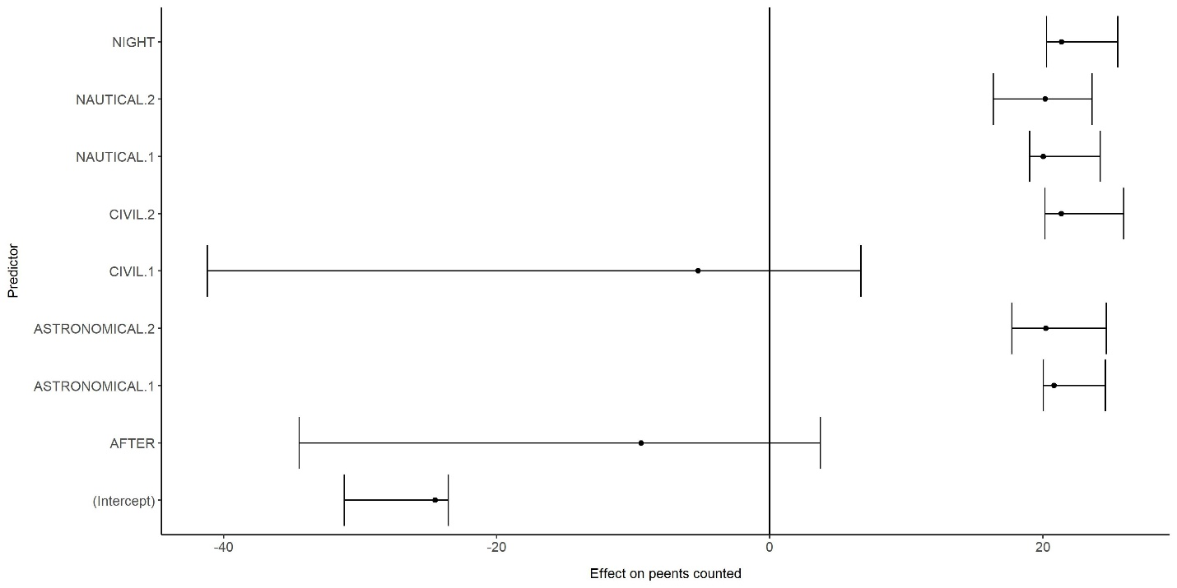

### Figure 1. Box plots showing the median, 5th and 95th quantile values for the model terms based on the 38 out of 100 bootstrapped sample data sets for which the following mixed model successfully converged and produced results: Peent activity rate = Twilight period. Note that in these results the “median” would be the mean of the two model coefficient values obtained for each fixed effect while the 5th and 95th quantiles would be respectively the lower and higher of the two model coefficient values. Effects of different twilight periods are relative to the 10-minute observation periods that took place before sunset (twilight period = “Before”).

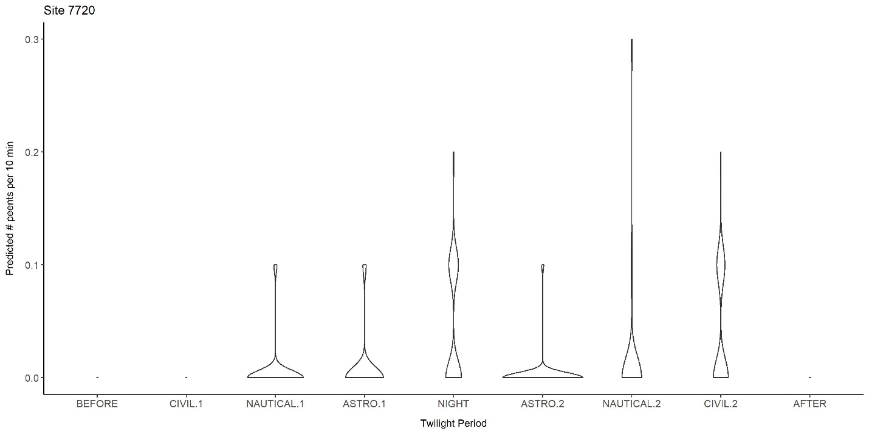

### Figure 2. Violin plots showing the distribution of predicted CONI boom activity rates (counts per 10-minute interval, rounded to 1 decimal place) in each of 9 twilight periods at each of 17 sites between ordinal days 170-190, based on the non-interaction mixed-effects model Peent Count ~ Twilight Period. Effects of different twilight periods are relative to the 10-minute observation periods that took place before sunset (twilight period = “Before”).

## Assessing Effects of Twilight Period and Latitude on Boom Activity Rates

In the non-interaction model, the model converged for all 100 bootstrapped sample data sets. Boom activity was generally highest in the civil twilight period right after sunset and secondarily highest in the nautical twilight period after midnight. Boom activity was predicted to be negligible in the “Night” twilight period and after sunrise (Figure 3-4). When I compared predicted boom activity rates to actual boom detections per 10-minute interval, Spearman correlations were moderately positive (median Spearman correlation = 0.24, 95 % BCI = 0.25 – 0.26).

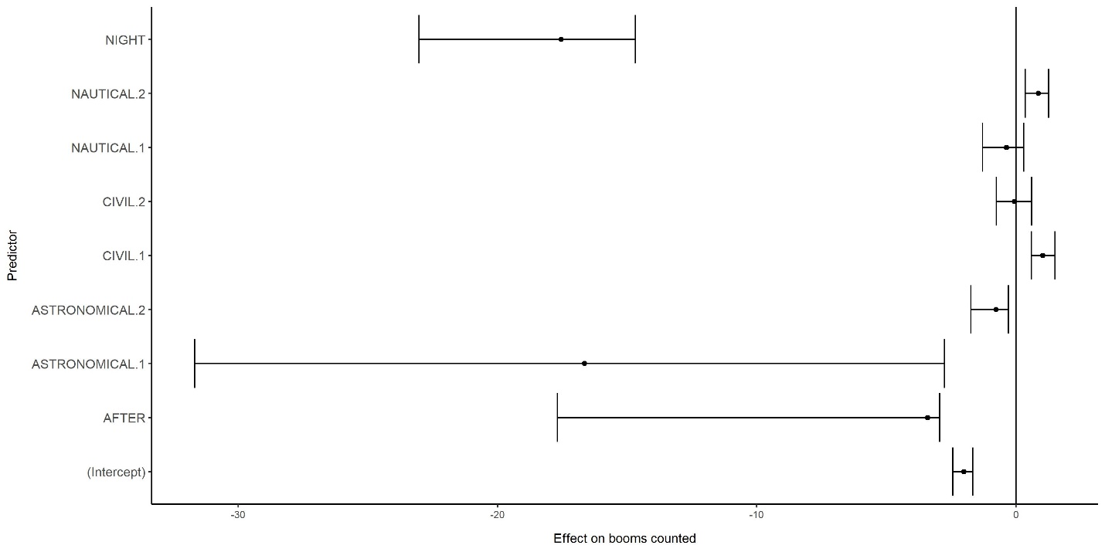

### Figure 3. Box plots showing the median, 5th and 95th quantile values for the model terms based on the 27 out of 100 bootstrapped sample data sets for which the following mixed model successfully converged and produced results: Boom activity rate = Twilight period. Effects of different twilight periods are relative to the 10-minute observation periods that took place before sunset (twilight period = “Before”).

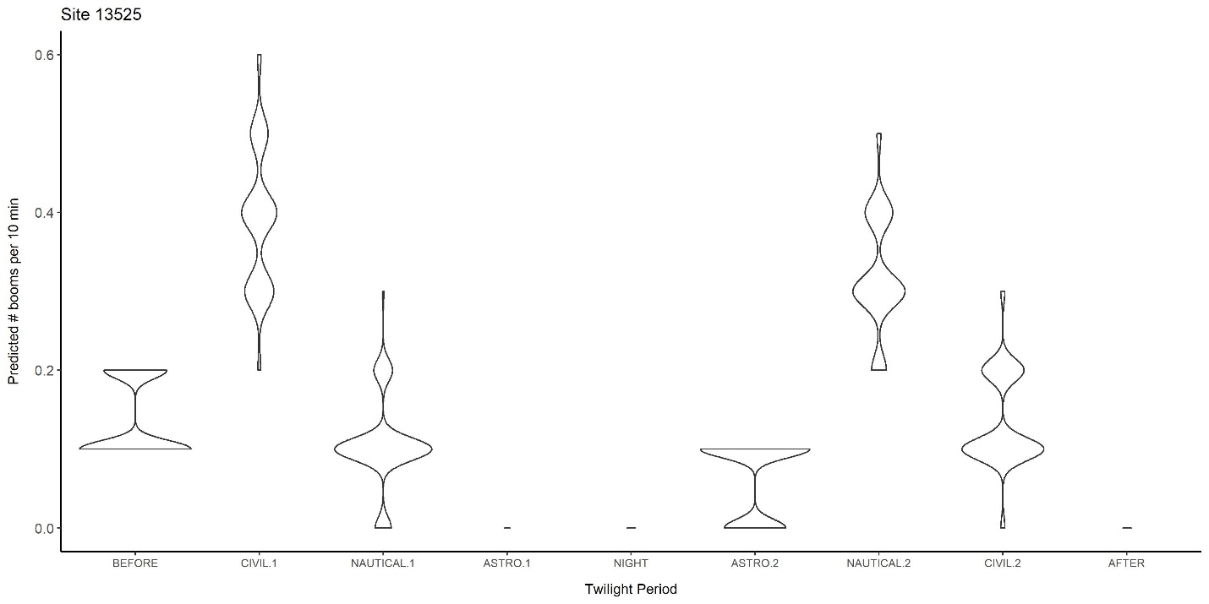

### Figure 4. Violin plots showing the distribution of predicted CONI boom activity rates (counts per 10-minute interval, rounded to 1 decimal place) in each of 9 twilight periods at each of 17 sites between ordinal days 170-190, based on the non-interaction mixed-effects model Boom Count ~ Twilight Period. Effects of different twilight periods are relative to the 10-minute observation periods that took place before sunset (twilight period = “Before”).

In the interaction model, only 27% of the boom activity models converged during bootstrapping. Based on these results, there was no strong evidence that twilight period effects on boom activity differed with latitude, although boom activity rates were lower at higher latitudes (Figure 5). When I compared predicted boom activity rates to actual boom detections per 10-minute interval, Spearman correlations were moderately positive (median Spearman correlation = 0.29, 95 % BCI = 0.27 – 0.31, higher than in the non-interaction model). As in the non-interaction model, boom activity was generally highest in the civil twilight period before midnight and secondarily highest in the nautical twilight period after midnight. Boom activity was predicted to be negligible in the “Night” twilight period and after sunrise (Figure 6).

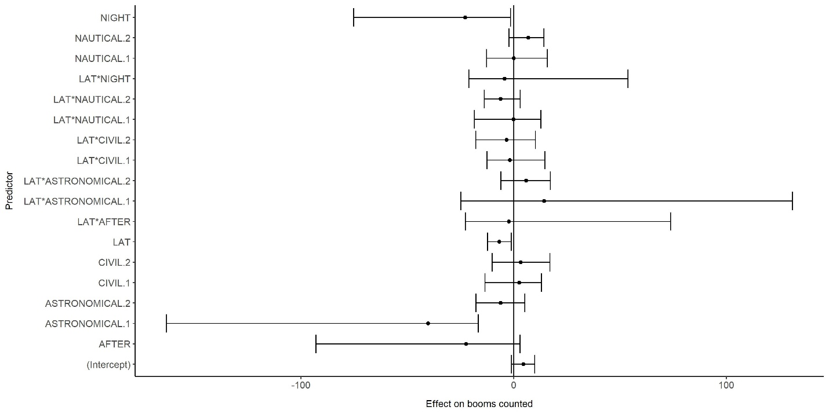

### Figure 5. Box plots showing the median, 5th and 95th quantile values for the model terms based on the 27 out of 100 bootstrapped sample data sets for which the following mixed model successfully converged and produced results: Boom activity rate = Twilight period + latitude + twilight period*latitude. Effects of different twilight periods and twilight period*latitude are relative to the 10-minute observation periods that took place before sunset (twilight period = “Before”).

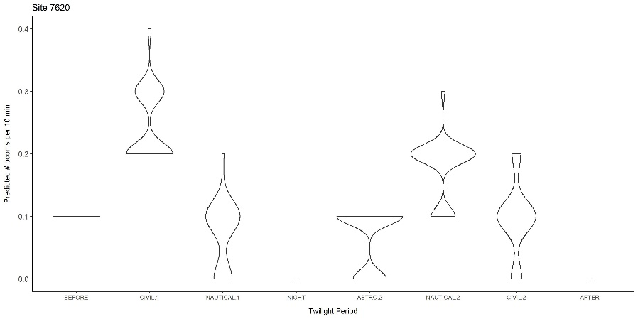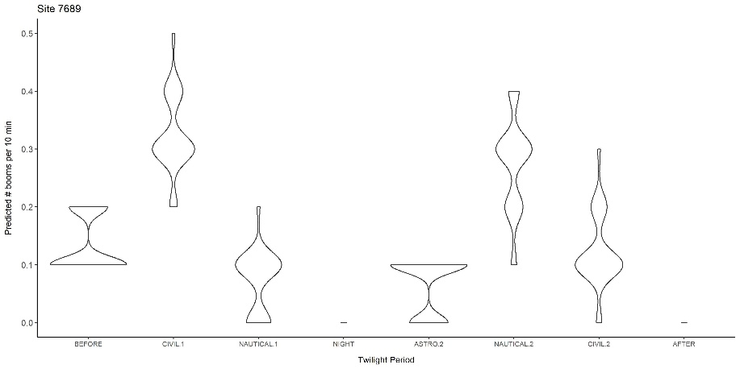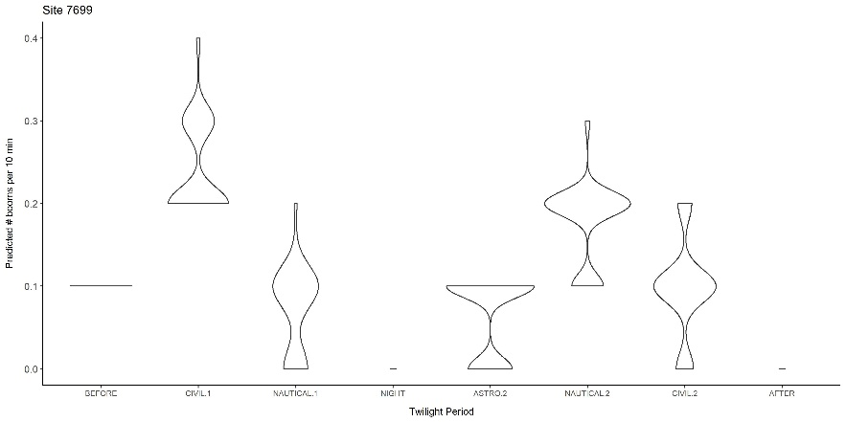 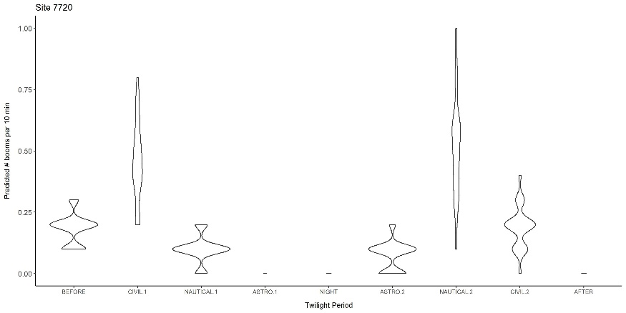

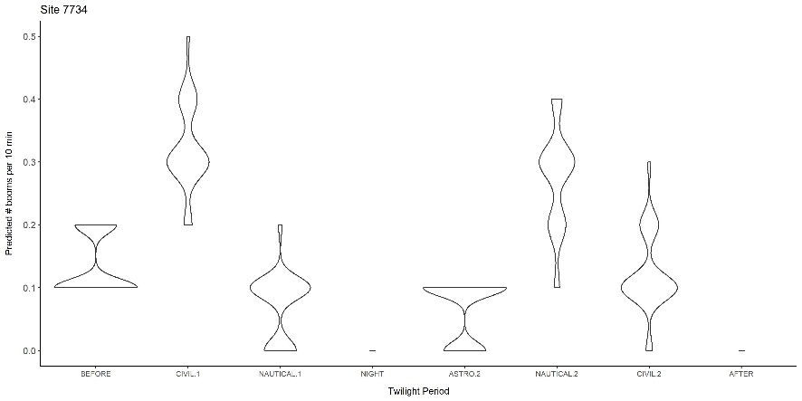 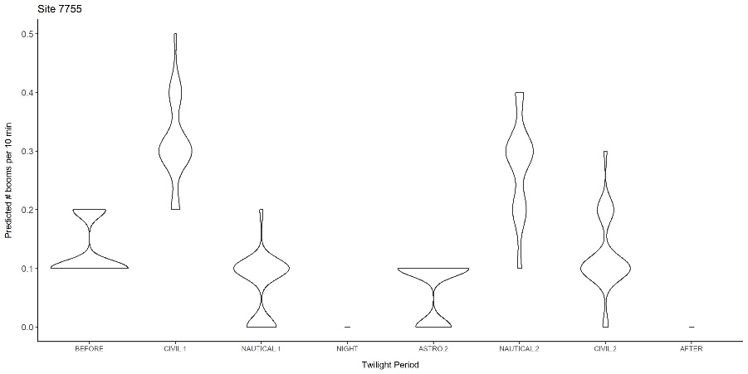

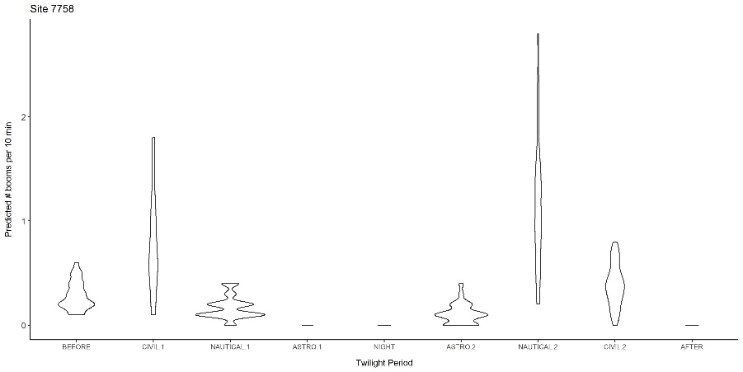 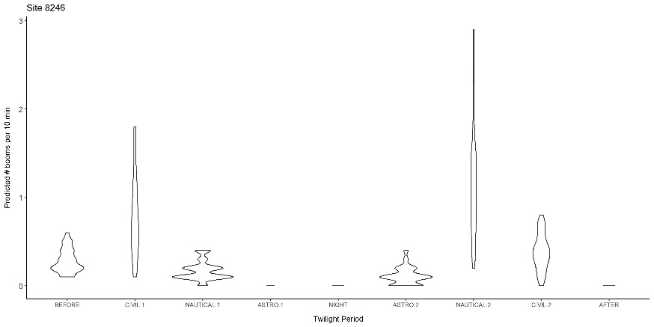

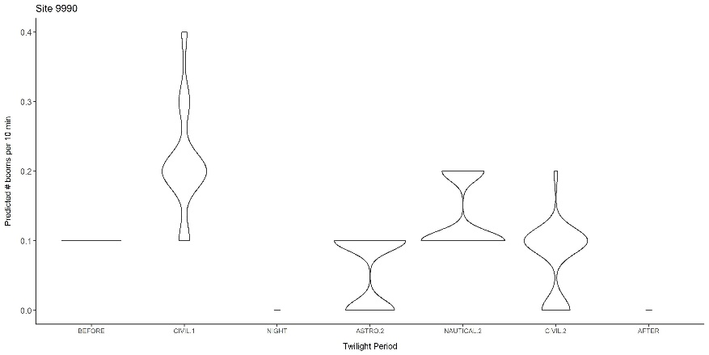 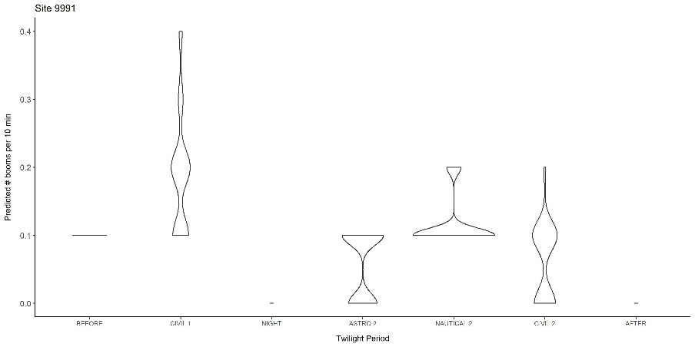

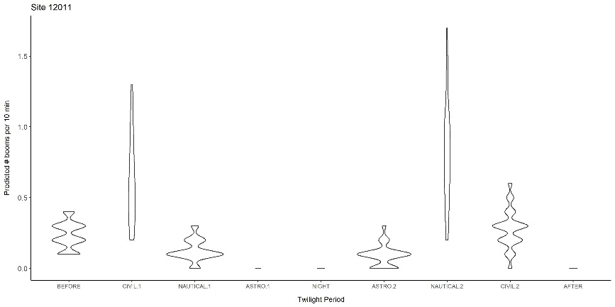 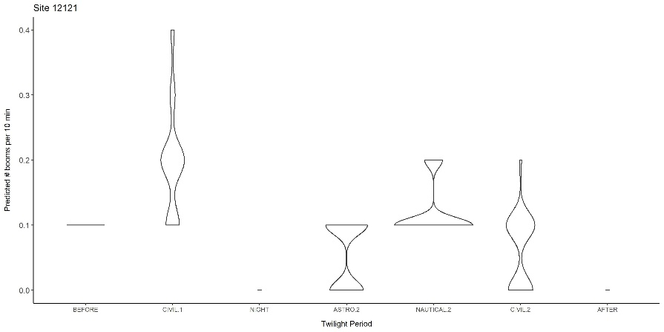

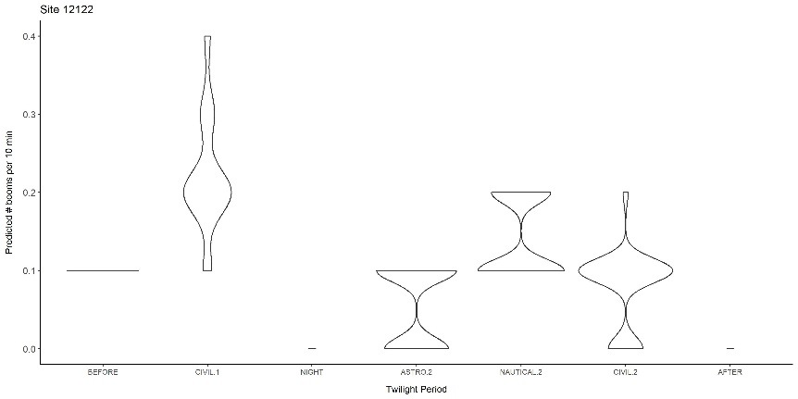 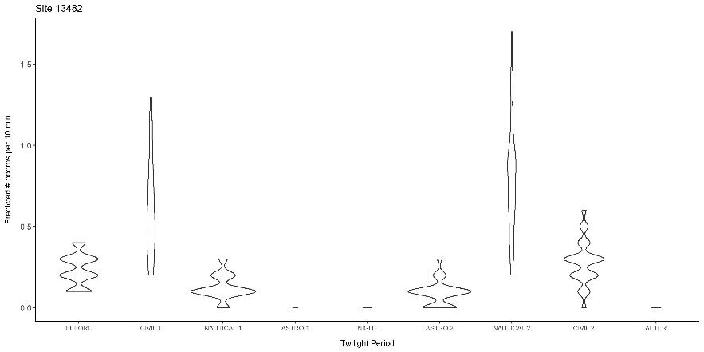

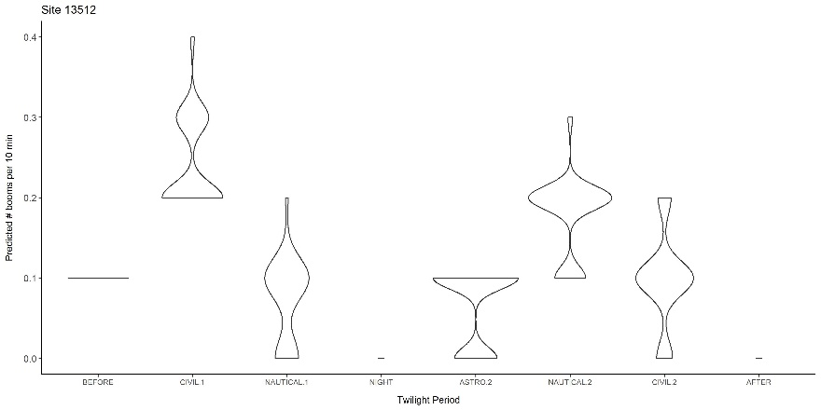 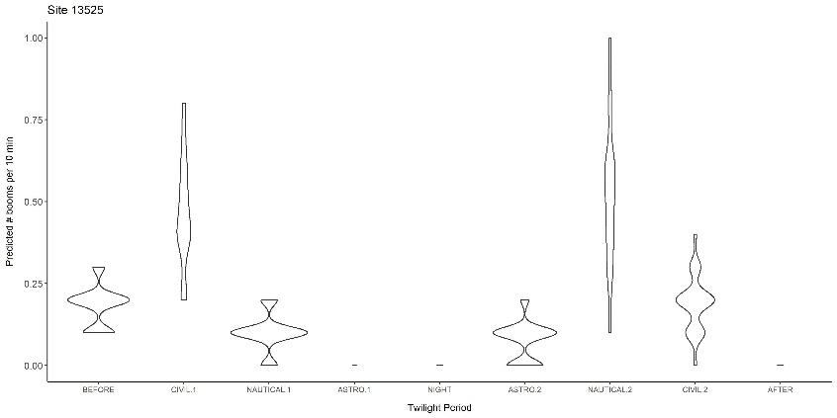

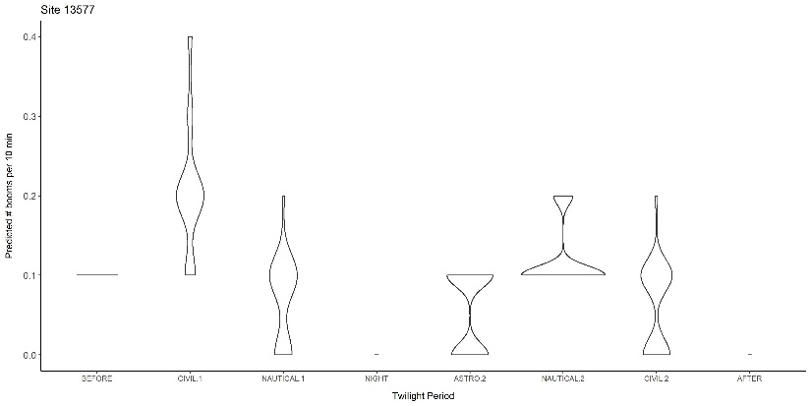

### Figure 6. Violin plots showing the distribution of predicted CONI boom activity rates (counts per 10-minute interval, rounded to 1 decimal place) in each of 9 twilight periods at each of 17 sites between ordinal days 170-190, based on the non-interaction mixed-effects model Boom Count ~ Twilight Period. Effects of different twilight periods are relative to the 10-minute observation periods that took place before sunset (twilight period = “Before”).

# Discussion

## Recommended Timing of CONI Surveys With Respect to Twilight Period

Twilight period models suggested that boom activity rates were consistently higher at sites in the civil twilight period immediately after sunset. While a secondary peak in activity existed at some sites, during nautical twilight after midnight, this period will probably be less convenient for people to go out and monitor CONI activity. CONI boom activity was predicted to be negligible after sunrise, in contrast to the singing activity of most songbirds in the breeding season. Thus, if the purpose of surveys is detection of CONI breeding behaviour, dedicated surveys at civil twilight will detect higher rates of boom activity and more evidence of breeding than will multi-species, all-purpose surveys that are tailored to songbirds. The lack of variation in twilight period effects with increasing latitude suggests that CONI surveys done during civil twilight are appropriate for the latitudes that we tested in our twilight period models.

# Citations

Agafonkin, V., & Thieurmel, B. (2017). suncalc: Compute sun position, sunlight phases, moon position, and lunar phase. R package version 0.3.

Barton, K., & Barton, M. K. (2019). Package ‘MuMIn’. R package version, 1(6).

Brigham, R. M., Ng, J., Poulin, R. G., & Grindal, S. D. (2011). Common Nighthawk (*Chordeiles minor*). In A. Poole, editor. The Birds of North America Online. Cornell Lab of Ornithology, Ithaca, NY, USA.

Burnham, K. P., & Anderson, D. R. (2004). Multimodel inference: understanding AIC and BIC in model selection. Sociological methods & research, 33(2), 261-304.

Buxton, R. T., & Jones, I. L. (2012). Measuring nocturnal seabird activity and status using acoustic recording devices: applications for island restoration. Journal of Field Ornithology, 83(1), 47-60.

Caccamise, D. F. (1974). Competitive relationships of the Common and Lesser Nighthawks. Condor, 76(1), 1-20.

Canaday, C. (1997) Loss of insectivorous birds along a gradient of human impact in Amazonia. Biological Conservation, 77, 63-77.

Charif, R. A., Waack, A. M., & Strickman, L. M. (2010). Raven Pro 1.4 User's Manual. Cornell Lab of Ornithology, Ithaca, NY. 367 pp.

Fiske, I., & Chandler, R. (2011). Unmarked: an R package for fitting hierarchical models of wildlife occurrence and abundance. Journal of statistical software, 43(10), 1-23.

Fletcher, Q. E., Fisher, R. J., Willis, C. K., & Brigham, R. M. (2004). Free-ranging common nighthawks use torpor. Journal of Thermal Biology, 29(1), 9-14.

Frommolt, K. H., & Tauchert, K. H. (2014). Applying bioacoustic methods for long-term monitoring of a nocturnal wetland bird. Ecological Informatics, 21, 4-12.

Frommolt, K. H. (2017). Information obtained from long-term acoustic recordings: applying bioacoustic techniques for monitoring wetland birds during breeding season. Journal of Ornithology, 158(3), 659-668.

Grolemund, G., & Wickham, H. (2011). Dates and times made easy with lubridate. Journal of Statistical Software, 40(3), 1-25.

Hallman, C. A., R. P. B. Foppen, C. A. M. van Turnhout, H. de Kroon, and E. Jongejans (2014) Declines in insectivorous birds are associated with high neonicotinoid concentrations. Nature, 511(7509), 341.

Nebel, S., A. Mills, J. McCracken, and P. Taylor (2010). Declines of aerial insectivores in North America follow a geographic gradient. Avian Conservation and Ecology, 5(2).

Oppel, S., Hervias, S., Oliveira, N., Pipa, T., Silva, C., Geraldes, P., Goh, M., Immler, E. & McKown, M. (2014). Estimating population size of a nocturnal burrow-nesting seabird using acoustic monitoring and habitat mapping. Nature Conservation, 7, 1.

Paquette, S. R., F. Pelletier, D. Garant, and M. Bélisle (2014). Severe recent decrease of adult body mass in a declining insectivorous bird population. Proceedings of the Royal Society B, 281, 20140649.

Robin, X., Turck, N., Hainard, A., Tiberti, N., Lisacek, F., Sanchez, J. C., & Müller, M. (2011). pROC: an open-source package for R and S+ to analyze and compare ROC curves. BMC bioinformatics, 12(1), 77.

Rosenberg, K. V., Dokter, A. M., Blancher, P. J., Sauer, J. R., Smith, A. C., Smith, P. A., Stanton, J. C., Panjabi, A., Helft, L., Parr. M, & Marra, P. P. (2019). Decline of the North American avifauna. Science, 366(6461), 120-124.

Sauer, J. R., Peterjohn, B. G., & Link, W. A. (1994). Observer differences in the North American breeding bird survey. The Auk, 111(1), 50-62.

Sekercioglu, C. H., P. R. Ehrlich, G. C. Daily, D. Aygen, D. Goehring, and R. F. Sandi (2002) Disappearance of insectivorous birds from tropical forest fragments. Proceedings of the National Academy of Sciences, 99, 263-267.

Smith, A. C., M.-A. R. Hudson, C. M. Downes, and C. M. Francis (2015) Change points in the population trends of aerial-insectivorous birds in North America: synchronized in time across species and regions. PLOS One, 10(7): e0130768. doi:10.1371/journal.pone.0130768.

Sólymos, P. (2017). <https://cran.r-project.org/web/packages/intrval/intrval.pdf>.

Tegeler, A. K., Morrison, M. L., & Szewczak, J. M. (2012). Using extended‐duration audio recordings to survey avian species. Wildlife Society Bulletin, 36(1), 21-29.

Weller, M. W. (1958). Observations of the incubation behavior of a Common Nighthawk. Auk, 75(1), 48-59.Wood, S., Scheipl, F., & Wood, M. S. (2017). Package ‘gamm4’. Am. Stat., 45, 339.

# Abbreviations Used in This Report

ARU = Acoustic or Autonomous Recording Unit

BBS = North American Breeding Bird Survey

CONI = Common Nighthawk (*Chordeiles minor*)

TSSS = Time Since Sunset